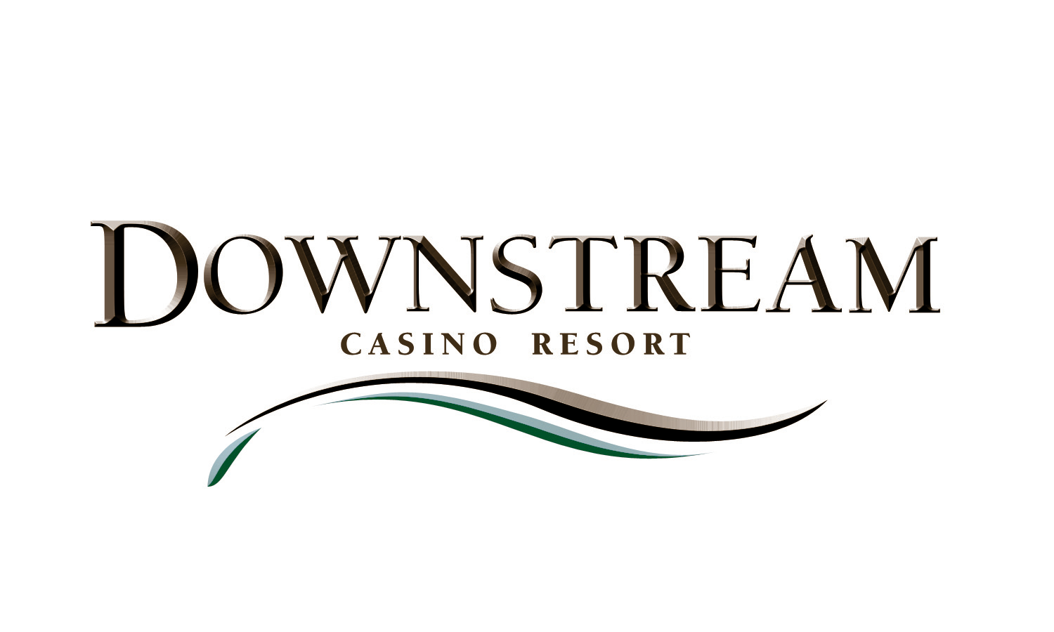

News Release

For more information:
Sean Harrison
Wireless (479) 236-3166

Email SeanH59@sbcglobal.net

DOWNSTREAM COMPLETES PURCHASE OF LOMA LINDA COUNTRY CLUB, PLANS IMPROVEMENTS AND UPGRADES

(March 21, 2008) – Downstream Casino Resort closed on the purchase of Joplin’s Loma Linda Country Club today. That made official what many people had speculated for months after the resort took over management of the 36-hole golf club late last year.

Initially, Downstream had planned to offer golf to its guests through a partnership arrangement with Loma Linda, located less than a mile away from the casino construction site. But officials later decided to purchase the property outright, said Downstream Chairman John Berrey.

“The more we looked at it and thought about how to make it work well for our customers, the more we realized we should just make it a permanent part of our amenities,” Berrey said.

He said Downstream will now make improvements to the country club’s two championship golf courses, cart paths, club house, pool and pool house facilities.

“Loma Linda has the potential to be a very nice golf facility, so we want to do some things that will put it on par with the rest of our upscale destination resort – no pun intended,” Berrey said. “And that means we will also look to reposition the country club, as far as marketing, since it is now part of Downstream Casino Resort.”

About Downstream Casino Resort
Downstream Casino Resort is a Las Vegas-style, upscale, destination resort ideally located just off I-44 at the spot where Kansas, Missouri and Oklahoma meet – a historic zone known as the Three States Area, about 7 miles west of the city of Joplin, Mo.
The resort is owned and operated by the Quapaw Tribe of Oklahoma, and the executive management team is comprised of seasoned gaming veterans from across the country. Projected opening of Phase One – almost 1,000,000 square feet, with a casino, hotel, restaurants, golf and shopping – is July 2008.
The Resort will include the following features during Phase One:
- A 70,000-square-foot casino floor with over 2,000 slot machines, 30 table games, a 14-table poker room, and a sports book.
- An Upscale Hotel with 226 rooms and Luxury suites, a VIP lounge, Retail shopping on the ground floor, Valet parking and high-end amenities.
- Five restaurants to include a fine dining steakhouse, a multi-station buffet restaurant, a sports bar and a 24-hour food court.
- A conference center with meeting rooms and catering services.
- Two 18-hole championship golf courses and a spa with an outdoor swimming pool.
- A fitness center and a salon & massage services will be added in Phase II.

- 30 -

