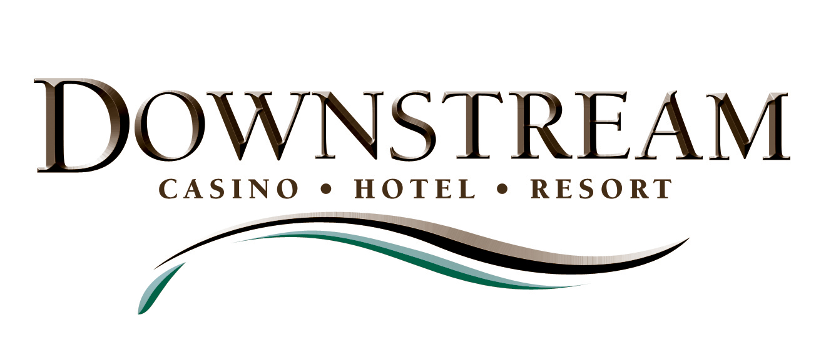

News Release

For more information:
Sean Harrison
Wireless (479) 236-3166

Email SeanH59@sbcglobal.net

Note: Photos included

DOWNSTREAM ADDS TO ITS EXECUTIVE TEAM; CASINO VETERANS ARRIVING FROM ALL PARTS OF THE COUNTRY

(February 14, 2008) –Downstream Casino Resort, in building its executive management team, continues to attract some of the country’s top casino professionals.

Timothy J. Brown, a veteran of Foxwoods Resort Casino in Mashantucket, Conn. – the largest casino resort in North America – and of the Seneca Allegany Casino and Hotel in New York State, has been hired as senior vice president of resort operations, Downstream announced.

Downstream also announced the hiring of Steve Hannemann, director of purchasing, and Robert Moritz, director of slots. Additional managers, as well as the hiring for numerous other positions, are expected soon as the resort prepares to open this summer at the Tri-State Corner just west of Joplin, Mo.

“We are attracting some of the best in the business from all over the country,” said John Berrey, chairman of the Downstream Development Authority, a subsidiary of the Quapaw Tribe of Oklahoma, which is building the resort and casino.

“When you’ve got a gaming legend like Mickey Brown as your senior project manager, and he brings in a top veteran like John Cirrincione as your general manager, that makes other proven professionals want to join your team and be part of your success story,” Berrey said.

Timothy Brown (Senior Vice President of Resort Operations), originally from Michigan, started his gaming career in hotel operations at the Golden Nugget in Atlantic City, N.J. He later became a hotel manager at Merv Griffin’s Resorts International in Atlantic City, and in 1993 joined the team that opened Foxwoods Resort Casino in Connecticut, where he was director of hotel operations overseeing three hotels, 1,400 rooms and suites, and 1,200 employees. Brown later became vice president of resort operations at the Seneca Allegany Casino and Hotel. He will be responsible for all non-gaming related departments and operations at Downstream.

Hannemann (Purchasing Director), originally of Ontario, Canada, has 15 years of experience as the chief purchasing and procurement manager in the casino industry, having worked at five major commercial casino resorts. Prior to that, he spent 10 years in construction and property development procurement. So his skills and experience are well suited to helping build and open the Downstream Casino Resort. Hannemann was previously the director of purchasing at Seminole Hard Rock Hotel & Casino at Hollywood, Fla., and held the same position at the Seneca Niagara Falls Gaming Corporation at Niagara Falls, N.Y.

Moritz (Slots Director), with roots in Bloomington , Minn., and Long Beach , Calif., has worked in Arizona Indian gaming for almost 20 years. Most recently he was slot director at Vee Quiva Casino in Laveen, Ariz. He also served as slot manager, acting casino manager and casino shift manager at the Desert Diamond Casino in Tucson.

- 30 -

