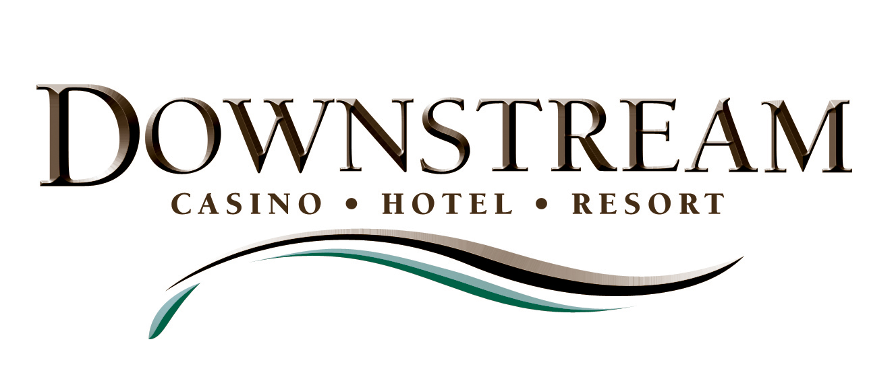

News Release

For more information:
Sean Harrison
Wireless (479) 236-3166

Email SeanH59@sbcglobal.net

Editors/News Directors Please Note: Feel free to download the graphic logo file at the top of this page to use for illustrative purposes. If you need a separate file, or a different type of file, please let me know. – Sean

DOWNSTREAM UNVEILS BRAND LOGO REFLECTIVE OF ITS SIGNIFICANCE, AMENITIES; RESORT SHOOTS FOR JULY 5 OPENING

(January 28, 2008) – The Downstream Casino Resort unveiled its newly developed brand logo to the public for the first time on Monday. Soon, the logo will appear in “help wanted” ads throughout the tri-state region as hiring begins in anticipation of a July 5 opening.

“Our marketing agency did a great job of listening to us, and capturing with this logo the essence of what we stand for – integrity, a very strong sense of community, a very upscale resort,” said Chairman John Berrey of the Downstream Authority.

“We felt it was important to unveil the logo in a way that we could explain its brand meaning, because Downstream is going to positively affect a lot of lives around the Tri-State region,” Berrey said.

Downstream is about more than gaming, he said. It is a force for economic growth in the surrounding communities; it is a great place to work; it is a fun place to visit for all sorts of entertainment including good restaurants, golf, a relaxing spa, concerts, and an upscale hotel unlike any in the region.

“And we want our brand to mean ‘good corporate citizenship’ too,” he said. “So we look forward to doing the things that will help people who need help in these communities.”

Downstream’s marketing agency, The Media and Marketing Group (M & M), of Cherry Hill, New Jersey, spent many hours over the past two months getting to know the Quapaw Tribe and hearing about what it wanted Downstream to mean.

“We created a logo that reflects the integrity and traditions of the Quapaw Tribe. The mark under the logo symbolizes a downstream flow and the coming together of three states in one unique destination,” said Frank Palmieri, president of The Media Marketing Group.

Downstream’s recently hired general manager, John Cirrincione, said he intends for the brand identity to have a strong and positive meaning for employees of the resort.

“If I’m doing my job right, then this logo will be a symbol of pride for our employees. They will feel like this is a great place to work, and when they are happy then our customers will have a good time, too,” Cirrincione said.

In the meantime, construction on the casino and hotel resort continues on schedule and on a pace to open on July 5, Chairman Berrey said. “The weather has been a challenge lately, but we are still hitting all of our schedule targets. We have been finalizing numerous details related to interior design on the casino and hotel. We are about to build a mock hotel room in a temporary building beside our construction trailers, so that will help us see exactly what the rooms will look like in every detail.”

About Downstream Casino Resort
Downstream Casino Resort is a Las Vegas-style, upscale, destination resort ideally located just off I-44 at the spot where Kansas, Missouri and Oklahoma meet – a historic zone known as the Three States Area, about 7 miles west of the city of Joplin, Mo.
The resort is owned and operated by the Quapaw Tribe of Oklahoma, and the executive management team is comprised of seasoned gaming veterans from across the country. Projected opening of Phase One – almost 1,000,000 square feet, with a casino, hotel, restaurants, golf and shopping – is July 2008.
The Resort will include the following features during Phase One:
- A 70,000-square-foot casino floor with over 2,000 slot machines, 30 table games and a 14-table poker room with sports book.
- An Upscale Hotel with 226 rooms and Luxury suites, a VIP lounge, Retail shopping on the ground floor, Valet parking and high-end amenities.
- Five restaurants to include a fine dining steakhouse, a multi-station buffet restaurant, a sports bar and a 24-hour food court.
- A conference center with meeting rooms and catering services.
- Two 18-hole championship golf courses and a spa with an outdoor swimming pool.
- A fitness center and a salon & massage services will be added in Phase II.

- 30 -

