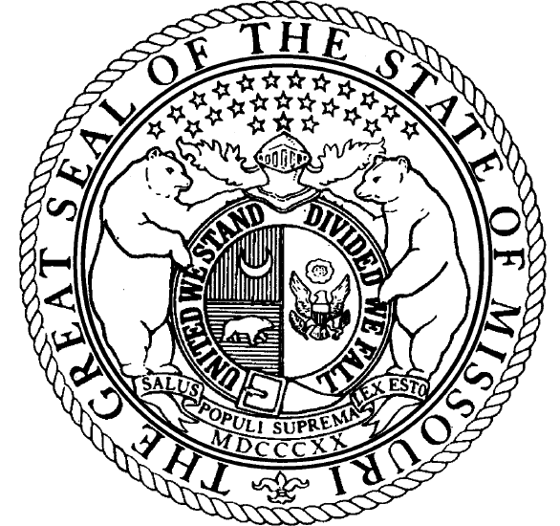
PRESS  RELEASE | From the Office of  Representative Marilyn Ruestman  131st District
FOR IMMEDIATE RELEASE:  March 12, 2008 |  | CONTACT: Jonathan Russell  573-751-9801
Commission Unanimously Approves Plans to Upgrade I-44 and
Route 166

JEFFERSON CITY – State Representative Marilyn Ruestman (R-131) is pleased to announce that today the Missouri Highways and Transportation Commission, in a unanimous vote, approved the plans that will improve access at Exit One of I-44 in Newton County to meet infrastructure needs. With the Quapaw Tribe of Oklahoma covering all costs for these upgrades no state funds will be used.

Representative Ruestman offers the following statement: “This is an excellent example of how public-private partnerships should work. I am excited to observe the explosion of employment and business growth in northern Newton County. My personal thanks to: Bruce Anderson, the Village of Loma Linda; Andy Nimmo, Redings Mill Fire Department; the Joplin Special Roads District; MoDOT; and John Berrey, Quapaw Tribe of Oklahoma for their cooperation which will result in improved safety and access.”

John Berrey, Chairman of the Quapaw Tribe, offers the following statement: “On behalf of the Quapaw Tribe of Oklahoma, we wish to thank Representative Ruestman for her support. These improvements to the I-44/SR 166/400 corridor will serve future transportation needs and meet her ultimate goal of increased safety.”

###

